**ANNUAL**

**REPORT**

**2015-16**

**RAHAT WELFARE FOUNDATION**

**G-25, First Floor, 40 feeta Road, Shaheenbagh,**

**Jasola-Kalindi Kunj Road, New Delhi - 110025**

**ORGANIZED HEALTH AWARENESS CAMP IN SOUTH DELHI:**

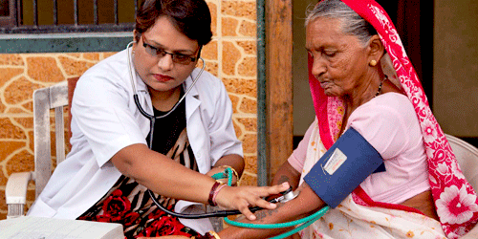

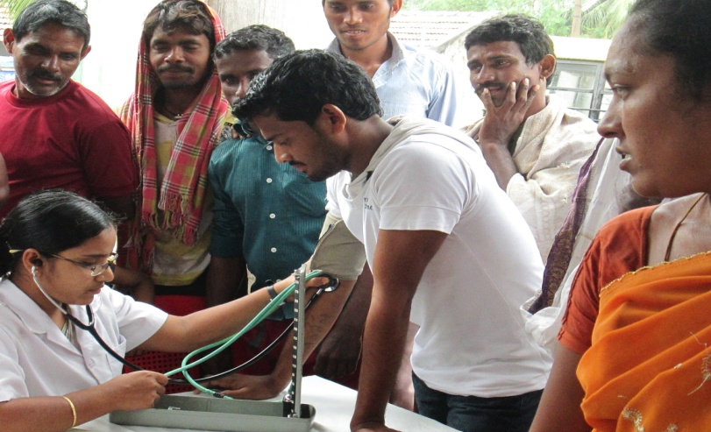On the occasion of World Health Day, the Foundation has held a health camp in the slum area of Tigri extension, New Delhi on 7th April, 2015. The physicians, dentist and other medical experts were present from the reputed hospitals like Batra, Dr RM Lohia Hospital, Safdarjung Hospital and Health Care Foundation etc. to check-up & diagnose the patients at free of cost. They also made them aware about the basic precautions from diseases, life-style, food habits etc.

Health has major worth in an individual’s life, since healthy body is an pre-requisite for healthy mind and this helps in preventing spread of various deadly disease, as we all know that ‘prevention is better than cure’. Because of lack of awareness & under awareness more often in village communities and also in the remote localities of a city, insanitation & unhygienic conditions is a common feature, which offers various injurious diseases. 150 ailing people participated during camp.

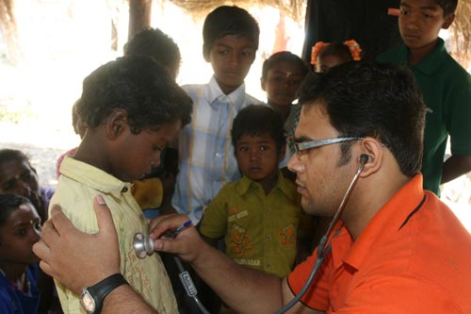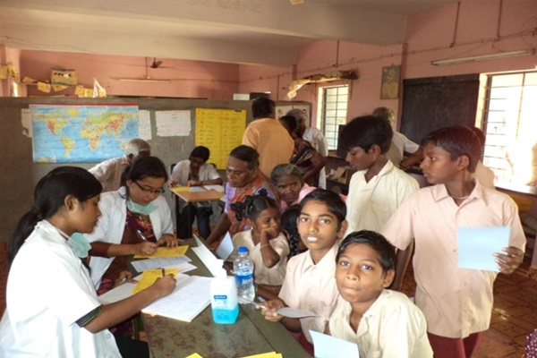

**Skill-up Trainings in Tailoring & Knitting**

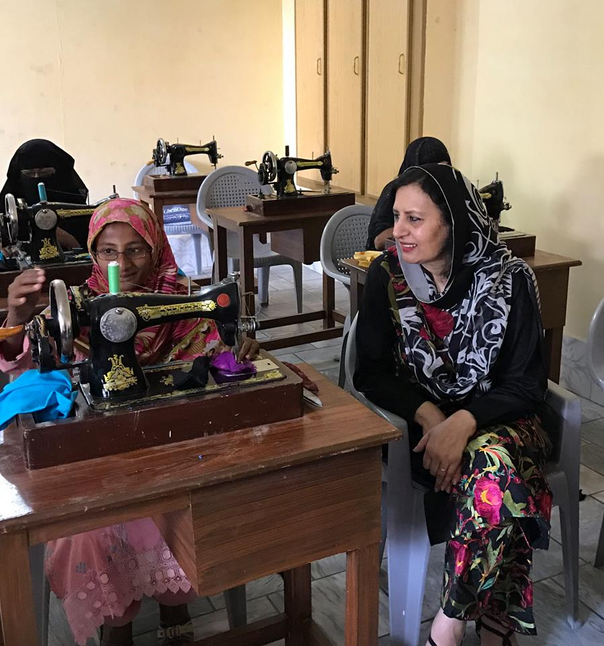

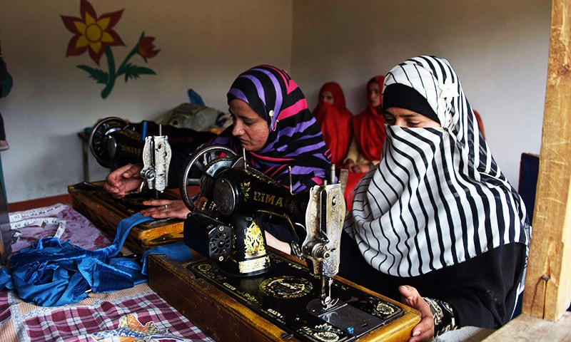Rahat believes that if you educate a man; you educate a man only but if you educate a woman; you educate a generation. Keeping this fact in mind we have commenced facilitating free trainings in Tailoring & Knitting at our office venue to the local deprived women and girls. The classes started on 20th September, 2014 and continued for about 03 months. In this period almost 40 women got training and benefited from this initiative.

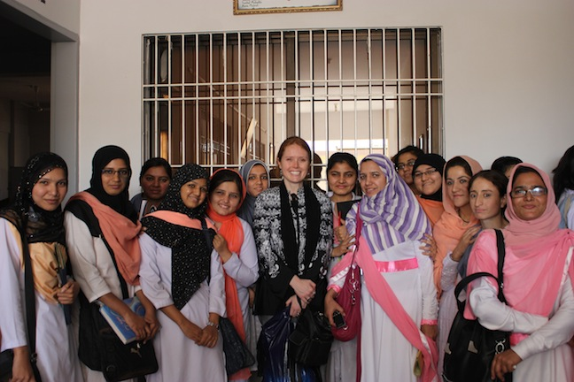The training enables the beneficiaries to be earning members of their families. The programme has raised confidence-level among the beneficiaries and motivated them to mobilize other such helpless females for joining such skill-up programs.

Women in general and minorities in special cases are passing through various types of family sufferings and monetary crisis in both urban slum settlements & rural parts of the country and they often found confined to homes, so are financially reliant on their husbands or other family members. These groups also are victims of domestic abuse.

**ECO-TOUR & BIRD WATCHING TRIP TO ARAVALI:**

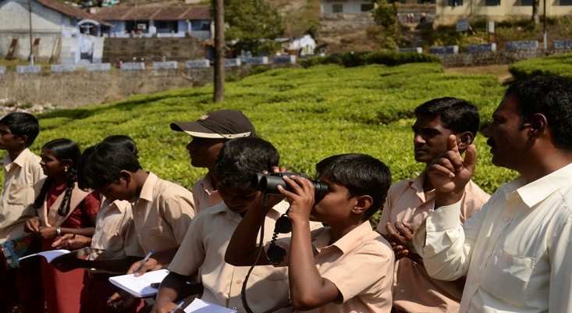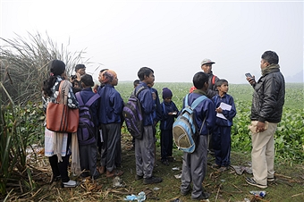22nd May, 2015 on the International Day of Biodiversity, Foundation has on organized an outreach activity for children and school going students to visit diminishing Aravali forests nearby Gurgaon, which despite erosion, dozens of rare birds and avi-fauna could be seen easily due to its vegetation and ecology. There are considerable numbers of endemic birds inhabiting these areas. Due to rapid loss of their natural habitat for erecting concrete forests, malls and ever-increasing environmental pollution, the bird & butterfly population of this region is declining day by day.

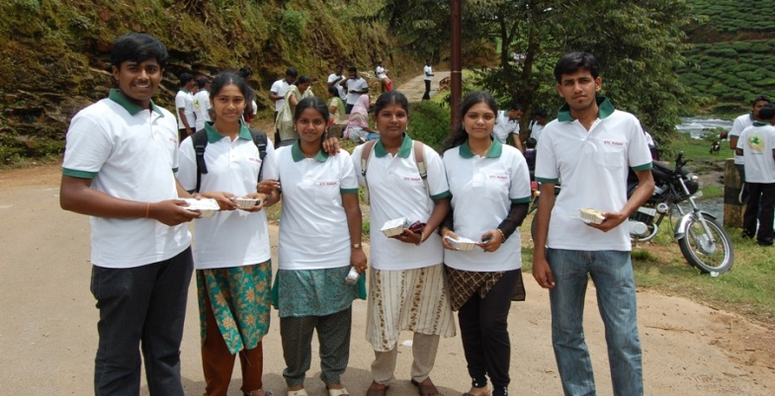

Keeping the fact, an information campaign become essential to raise awareness amongst the younger generation for protecting the same. Students were made familiar about the habitat of birds & their lifecycle by our team and wildlife scholars. The children were highly keen to see these colorful birds & shown tremendous eager to know the detailed facts.

The children have undertaken following activities:

I. Prepared Checklist of Birds

ii. Seasonal variations of birds

iii. Breeding season & nesting patterns of birds

iv. Habitat distribution of birds etc.

**PLANTATION & GREENING DRIVE IN FARIDABAD:**

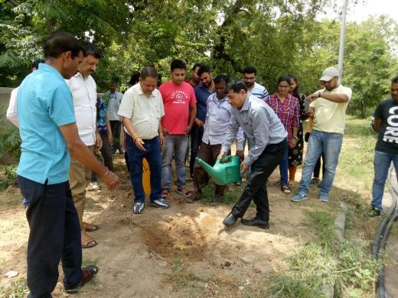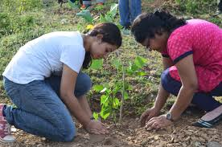The Foundation has marked celebration of World Environment Day on 5th June, 2015 and we have undertaken plantation movement involving hundreds of youth of residential colonies of new industrial township, Faridabad. The tree saplings were sponsored by the district horticulture department. The greening campaign was inaugurated by Shri Jashmit Singh General Secreatry FIA and MD JCB India Ltd. Ballabgarh. Speaking on the occasion he inspired students, youth & the local gathering to take oath not only to plant trees but also conserve them. The Special Guest Sh. BK Singh, SHO emphasized planting more no of trees in their respective areas to ensure ecological balance.

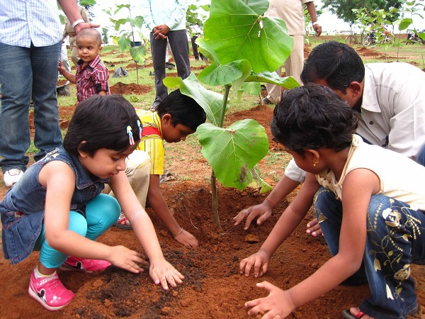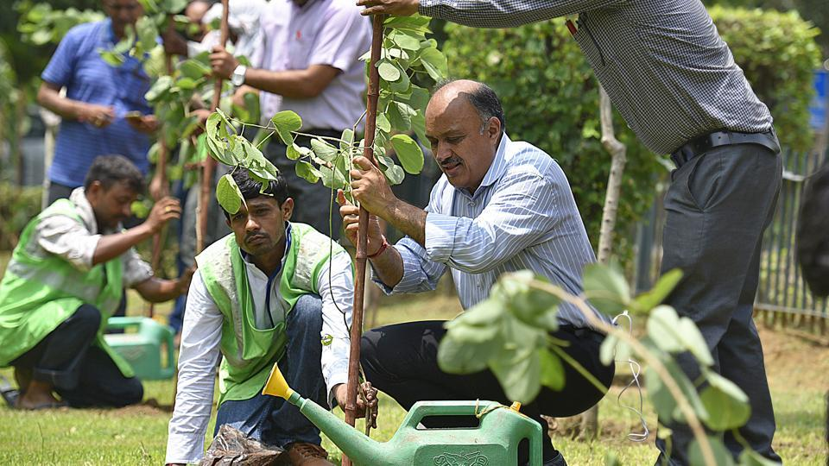

**Involved attempt towards tree plantation**

**ART COMPETITION ON SOCIAL WORK FOR CHILDREN:**

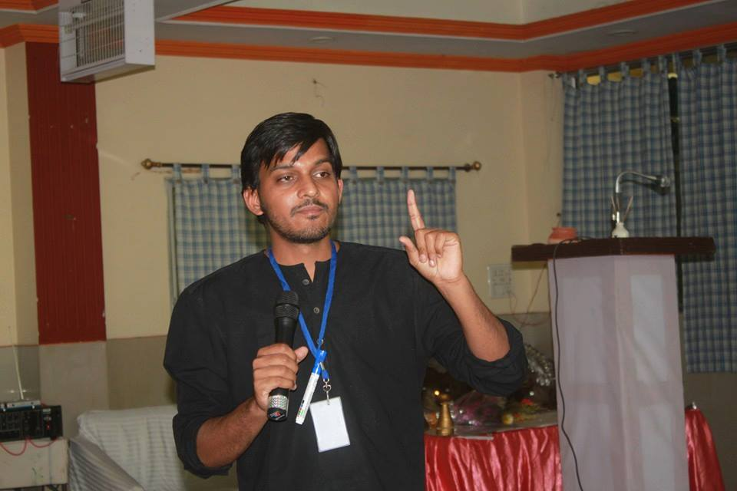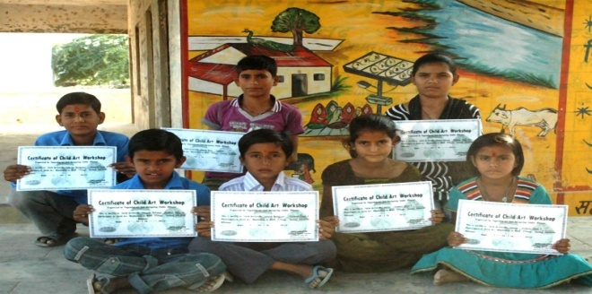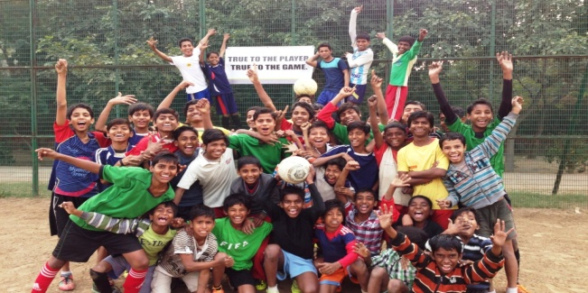The Foundation with the intention to raise awareness on social work & philanthropy amongst new generation, organized a painting competition. This was participated by about 220 children and shared their pictorial view on the issue. The program was inaugurated by the chief guest Mr RP Singh, President SBS and he appreciated the effort of the Foundation and provided certificates to all the kids and winning prizes to 5 students. While speaking on the occasion, Mr Singh described the significance of kindness, helpfulness and charitable activities to the children and their interrelationship with our ethos. He called-up children that you are the savior of society, so always try to help someone ask for your help and start this genuine activity from your home & schools.

**SAVE YAMUNA SHRAMDAAN:**

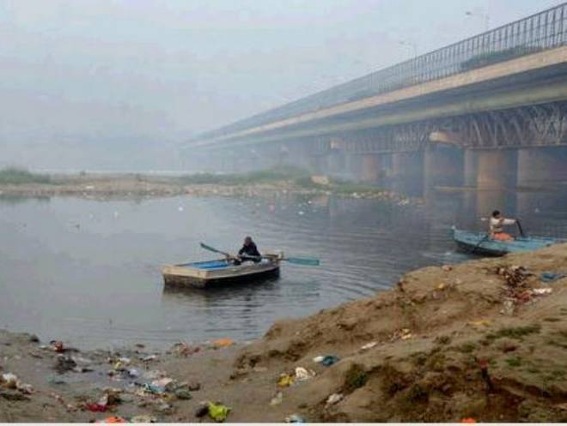Looking the day by day worsening state of River Yamuna, we have conducted the Safai Shramdaan on 22nd February, 2016 along with the involvement of other local ngos, organizations and schools. Hundreds of youth, students and local residents participated actively in the event. About 300 students from nearby schools along with their teachers were dynamically made a collective attempt to clean a bit kalindi kunj stretch of River Yamuna.

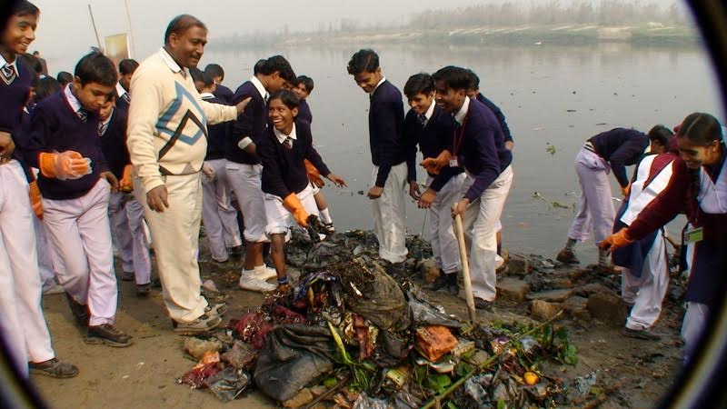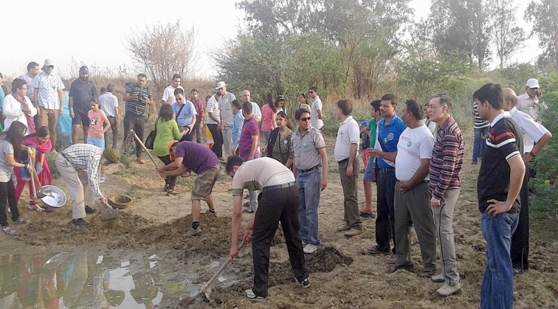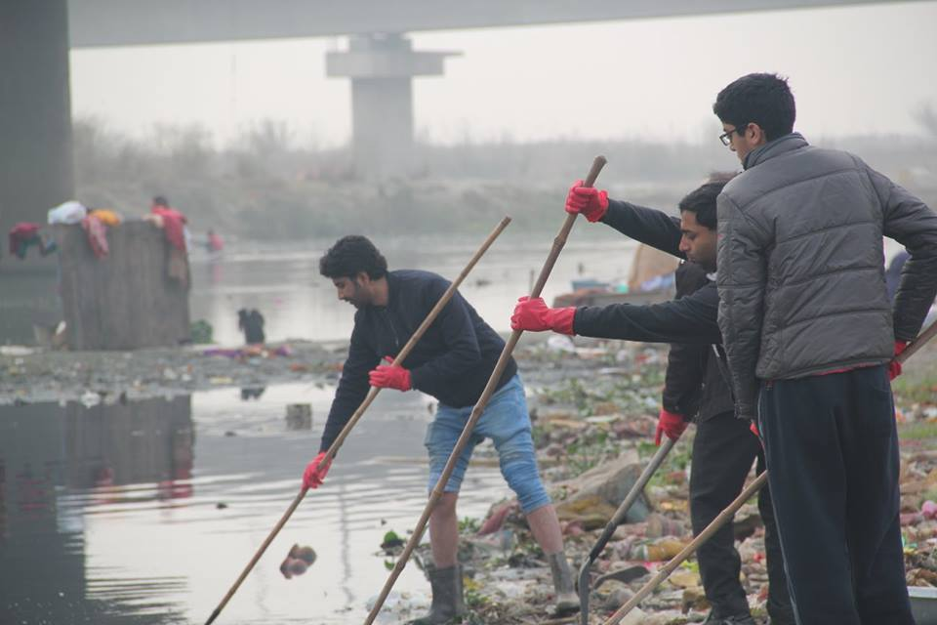The Yamuna river, often called Delhi’s lifeline, is gasping for life. The 22-km stretch along the national capital has virtually no aquatic life - thanks to over 20 drains that pour untreated sewage and other waste into the river. It is not that the Yamuna River has no aquatic life at all. Upstream from Wazirabad, before the river enters Delhi, it is home to turtles, different species of fish, crocodiles and an abundance of aquatic plants and phytoplankton. But as it enters Delhi, the river starts to die. Noted ecologist C.R. Babu says that the river is in fact “ecologically dead” in the 22 km urban stretch - between the Wazirabad and Okhla barrages. “Downstream from Wazirabad, the river is ecologically dead as it has no aquatic life. Low levels of dissolved oxygen (DO) and a very high degree of pollution are the reasons that killed the river,” Babu said.

A retired Delhi University professor, Babu says that sewage from 21 nullahs (drains) flow into the river, polluting it to a level that is enough to kill the components essential for maintaining aquatic life. The 21 nullahs discharge around 850 MGD (million gallons per day) of sewage into the Yamuna every day. Of these drains, 67 per cent pollution is caused by the Najafgarh drain alone. The stench emanating from the river can make one nauseous.

CCCCCCCCCCCCCCCCCCCCCCCCCCCCCCCCCCCCCCC